**Exercise 2: E-commerce Platform Search Function**

**EcommerceSearch.java**

import java.util.Arrays;

import java.util.Comparator;

public class EcommerceSearch {

static class Product {

int productId;

String productName;

String category;

public Product(int productId, String productName, String category) {

this.productId = productId;

this.productName = productName;

this.category = category;

}

public String toString() {

return "ID: " + productId + ", Name: " + productName + ", Category: " + category;

}

}

public static Product linearSearch(Product[] products, String name) {

for (Product p : products) {

if (p.productName.equalsIgnoreCase(name)) {

return p;

}

}

return null;

}

public static Product binarySearch(Product[] products, String name) {

int low = 0;

int high = products.length - 1;

while (low <= high) {

int mid = (low + high) / 2;

int cmp = products[mid].productName.compareToIgnoreCase(name);

if (cmp == 0) return products[mid];

else if (cmp < 0) low = mid + 1;

else high = mid - 1;

}

return null;

}

public static void main(String[] args) {

Product[] products = {

new Product(101, "Laptop", "Electronics"),

new Product(102, "Shampoo", "Personal Care"),

new Product(103, "Chair", "Furniture"),

new Product(104, "Keyboard", "Electronics"),

new Product(105, "Notebook", "Stationery")

};

System.out.println("=== Linear Search ===");

Product result1 = linearSearch(products, "Chair");

System.out.println(result1 != null ? result1 : "Product not found");

Arrays.sort(products, Comparator.comparing(p -> p.productName.toLowerCase()));

System.out.println("=== Binary Search ===");

Product result2 = binarySearch(products, "Chair");

System.out.println(result2 != null ? result2 : "Product not found");

}

}

**Output :**

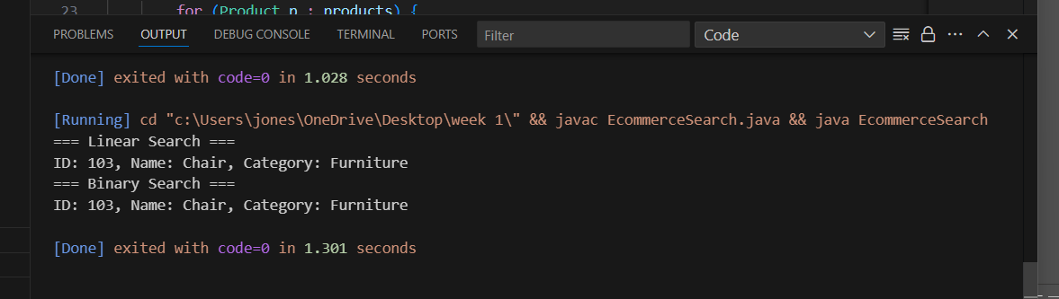

**Exercise 7: Financial Forecasting**

**FinancialForecast.java**

import java.util.Scanner;

public class FinancialForecast {

public static double calculateFutureValue(double value, double rate, int time) {

return (time == 0) ? value : calculateFutureValue(value, rate, time - 1) * (1 + rate);

}

public static void main(String[] args) {

Scanner input = new Scanner(System.in);

System.out.print("Enter present value (in rupees): ");

double principal = input.nextDouble();

System.out.print("Enter annual growth rate (in percent): ");

double rate = input.nextDouble() / 100;

System.out.print("Enter number of years: ");

int time = input.nextInt();

double result = calculateFutureValue(principal, rate, time);

System.out.printf("Projected value after %d years: %.2f\n", time, result);

}

}

**Output :**

